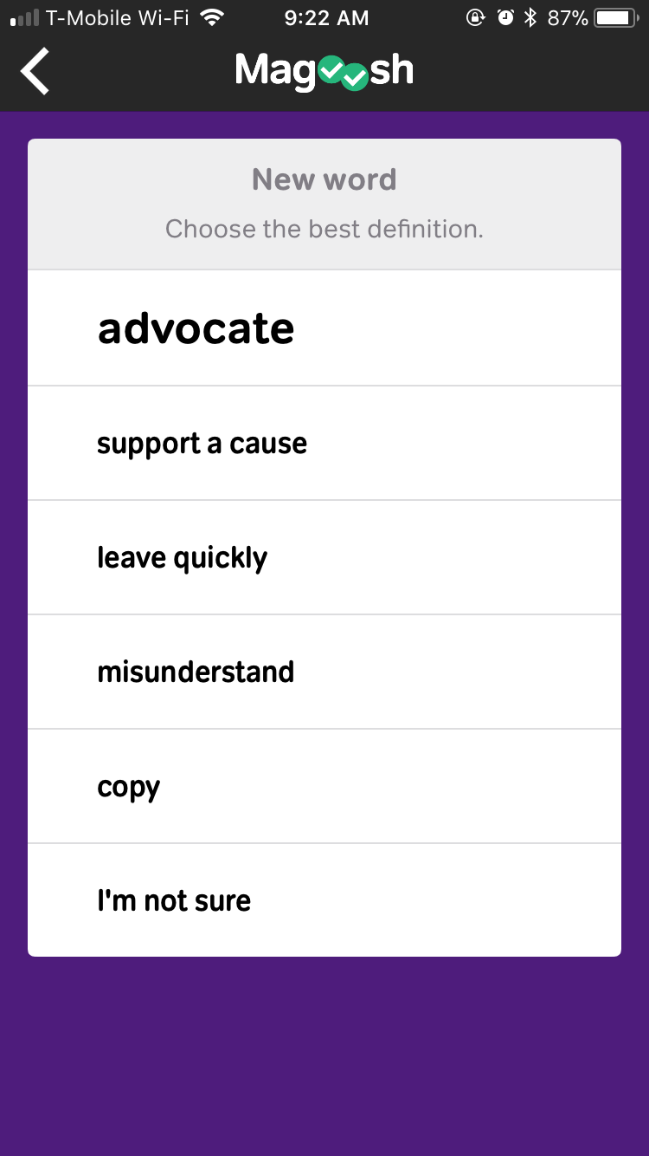
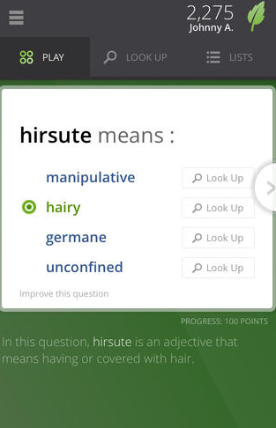

.App {
text-align: center;
}
.App-logo {
animation: App-logo-spin infinite 20s linear;
height: 80px;
}
.App-header {
background-color: #222;
height: 150px;
padding: 20px;
color: white;
}
.App-title {
font-size: 1.5em;
}
.App-intro {
font-size: large;
}
@keyframes App-logo-spin {
from { transform: rotate(0deg); }
to { transform: rotate(360deg); }
}

